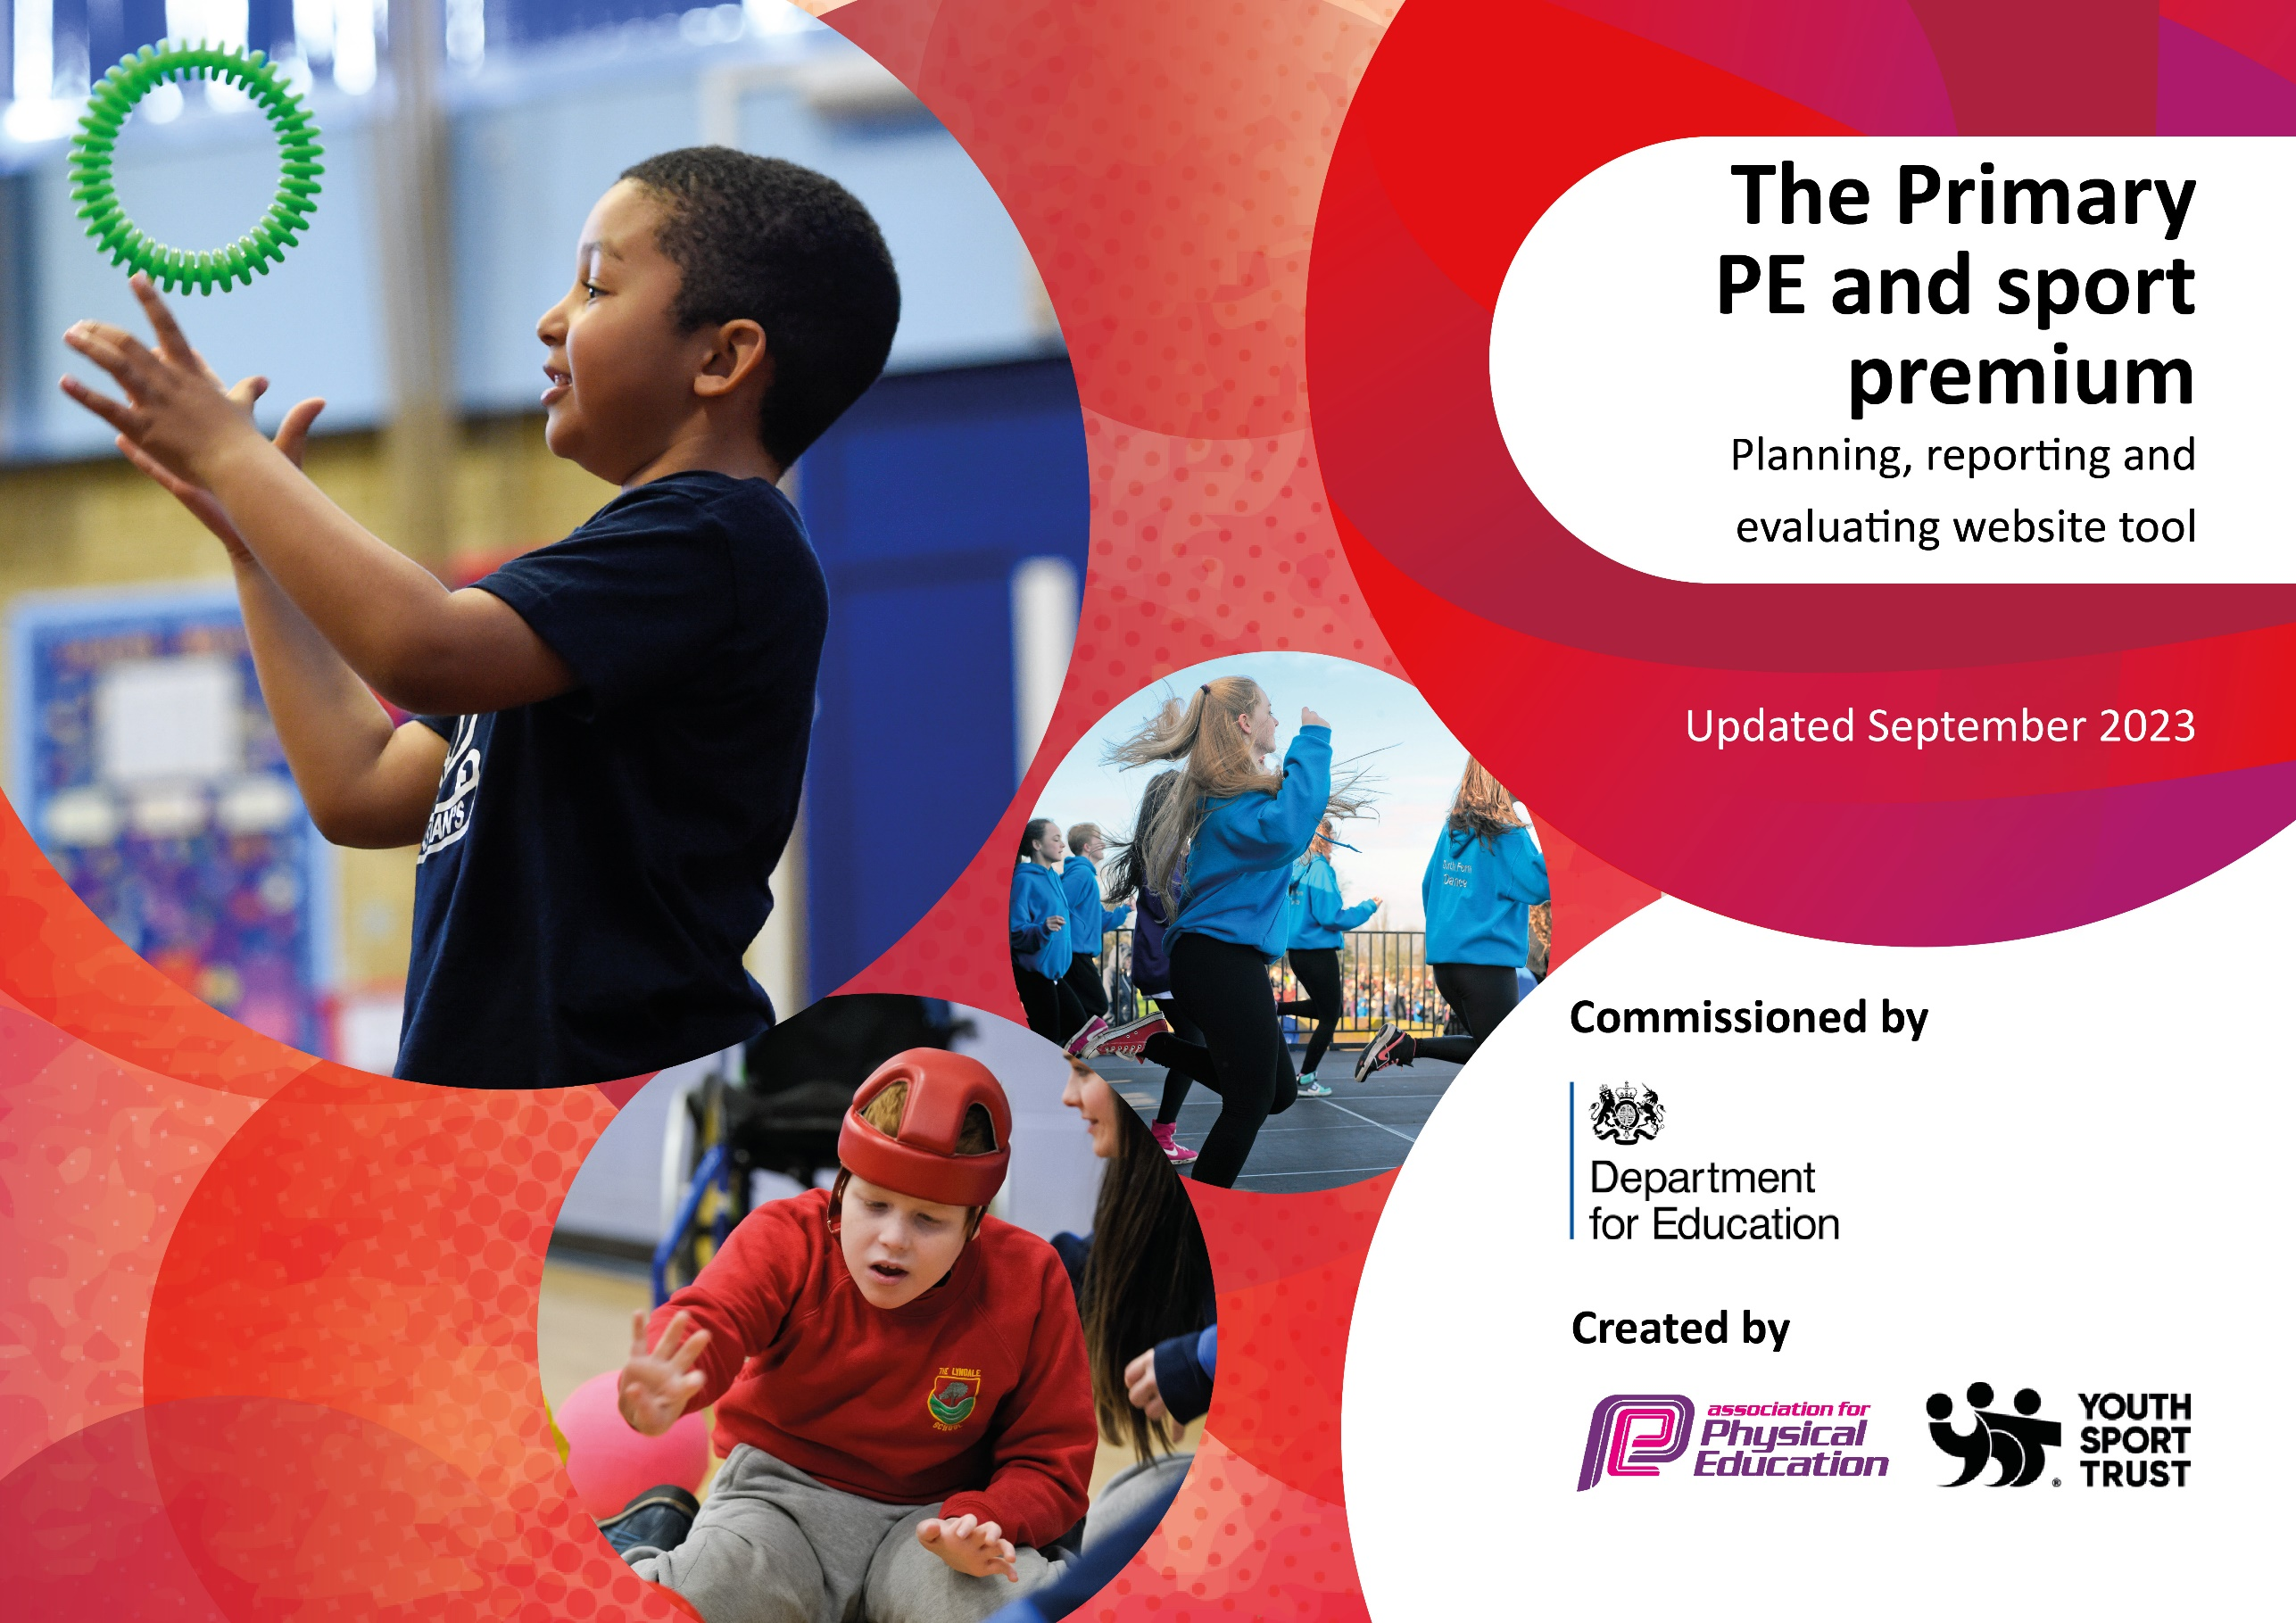

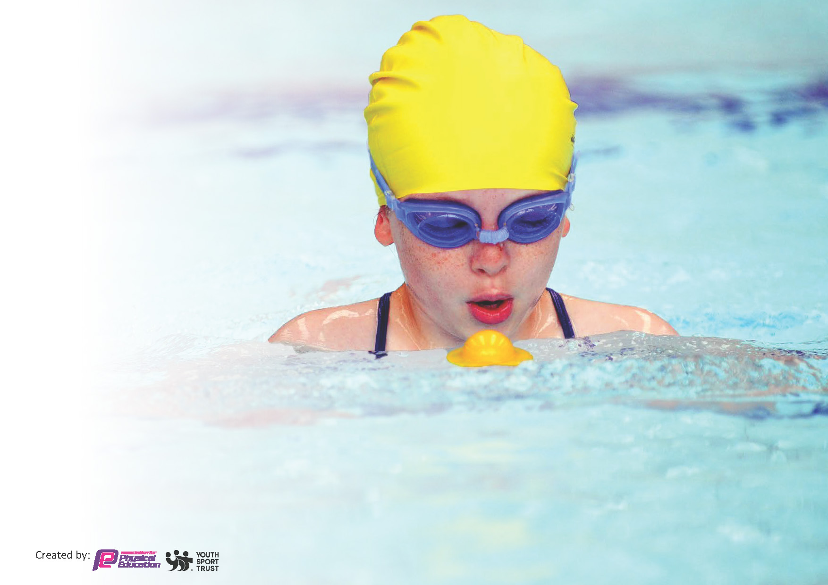
This template can be used for multiple purposes:
by:
- It enables schools to effectively plan their use of the Primary PE and sport premium
- It helps schools to meet the requirements (as set out in guidance) to publish information on their Primary PE and sport premium
- It will be an effective document to support Ofsted inspections enabling schools to evidence progress in Physical Education (PE) and evidence swimming attainment, which forms part of the PE National Curriculum. We would recommend schools consider
the Intent, Implementation and Impact of any spend, as examined within the Education Inspection Framework.

It is important that your grant is used effectively and based on school need.

Schools must use the funding to make additional and sustainable
improvements to the quality of the PE, School Sport and Physical Activity (PESSPA)
they offer. This means that you should use the Primary PE and sport premium to:

- Build capacity and capability within the school to ensure that improvements made now will benefit pupils joining the school in future years
- Develop or add to the PESSPA activities that your school already offers.

The Primary PE and sport premium should not be used to fund capital spend projects; the school’s core budget should fund these. Further detail on capital expenditure can be found in the updated Primary PE and sport premium guidance.

The Primary PE and sport premium guidance, outlines 5 key priorities that funding should be used towards. It is not

necessary that spending has to meet all the key priorities, you should select the priorities that you aim to use any funding towards.

Although completing this template is not a requirement for schools, schools are required to publish details of how they spend this funding. Schools must also outline what the impact this funding has had on pupils’ PE and sport participation and attainment and how any spending will be sustainable in the future. All funding must be spent by 31st July 2024.

The Department for Education has worked closely with the Association for Physical Education (afPE) and the Youth Sport Trust (YST) to develop this template and encourages schools to use it. This template is an effective way of meeting the reporting requirements of the Primary PE and sport premium.
Review of last year’s spend and key achievements (2023/2024)

We recommend you start by reflecting on the impact of current provision and reviewing your previous spend.

Activity/Action | Impact | Comments
Medals introduced for Daily mile and Daily mile timetabled for every KS2 class on non PE days.  More / new clubs introduced.  More sports competitions entered.  CPD for teachers pn teaching the PE curriculum and also cross-curricular orienteering.  Play-leaders trained to encourage physical activity during lunch times.  Active assemblies introduced. | Being active during the school day has become an expectation and is a natural part of the day for all pupils. They expect to be active during the day.  More children attend a range of active clubs during the day across KS1 and KS2. Children enjoy these clubs.  More children are having the opportunity to attend competitive sports events.  Children are more active during lunch breaks and playtimes. | During the next academic year we will aim to build on this years’ progress and further extend the extent to which the children are able to be active during the school day.

Key priorities and Planning
This planning template will allow schools to accurately plan their spending.

Action – what are you planning to do | Who does this action impact? | Key indicator to meet | Impacts and how sustainability will be achieved? | Cost linked to the action
Training for midday supervisors to lead physical activities with KS2 during lunch breaks.  Training for Y6 sports leaders to lead physical activities with EYFS and KS1 during lunch breaks.  Purchase medals to encourage children to run more than walk during the Daily Mile in KS2. | Lunchtime supervisors - as they need to lead the activity  KS2 pupils – as they will take part.  Year 6 pupils as they will be leading the activities.  EYFS and KS1 pupils as they will take part in the activities.  KS2 children | Key indicator 2 -The engagement of all pupils in regular physical activity.  Key indicator 4: Broader experience of a range of sports and activities offered to all pupils.  Key indicator 2 -The engagement of all pupils in regular physical activity.  Key indicator 4: Broader experience of a range of sports and activities offered to all pupils.  Key indicator 2 -The engagement of all pupils in regular physical activity. | More pupils meeting their daily physical activity goal, more pupils encouraged to take part in PE and Sport Activities.  More pupils meeting their daily physical activity goal, more pupils encouraged to take part in PE and Sport Activities.  More pupils meeting their daily physical activity goal, more pupils encouraged to take part in PE and Sport Activities. | PE lead to train staff (cost of supply to cover class teacher)  Cost of equipment to deliver activities £800  Cost of equipment to deliver activities £800  Cost of medals - £700

Investigate new PE scheme of work to reinvigorate the current teaching of PE across the school. This will include CPD for staff.  Provide as wide a range of physical clubs before and after school as possible. Employ coaches/ instructors where necessary.  Provide as many opportunities as possible for as many children as possible to attend competitive sporting events. | All teachers and HLTAs who teach PE – they will all have some CPD.  All children will benefit from the new scheme of work.  All children in the school.  As many children as possible in school including SEND children. | Key Indicator 1: Increased confidence, knowledge, and skills of all staff in teaching PE and sport.  Key Indicator 4: Broader experience of a range of sports and activities offered to all pupils  Key Indicator 5: Increased participation in competitive sport | Class teachers and HLTAs in school more confident to deliver effective PE supporting pupils to undertake extra activities inside and outside of school.  Opportunities for more children to access a wider range of physical activities  Children of all ages and abilities within school | Cost of new scheme and CPD. £800  Cost of new equipment needed to deliver new scheme.  £1500  Wages for coaches and additional staff to lead clubs and activities.  £6000  Subscription costs  Transport costs  Cost of supply cover to cover staff supervising children at the events  £7080

Key achievements 2023-2024
This template will be completed at the end of the academic year and will showcase the key achievements schools have made with their Primary PE and sport premium spending.

Activity/Action | Impact | Comments
Midday supervisors leading lunch time physical activities, including using the boom box every Friday for dancing in the playground.  Playleaders leading physical activities every lunch break with KS1.  More before and after school clubs and more variety of clubs where children can be physically active.  Increased number of sports competitions throughout the year.  CPD for all teaching staff using Real PE scheme of work. CPD for gymnastics club leader. | More children active during lunchtimes.  More children physically active before and after school hours.  More children participating in sports competitions including children with SEND.  Staff more proficient and confident at teaching PE. | A successful year regarding making sure that all children are more active during the school day and more children have the opportunity to represent the school at sporting competitions.  Next year we intend to continue with this journey. We will continue to offer as many physical activity clubs as we can. We intend to include more active lessons during the school day and we are investing in a new PE scheme to re-invigorate the PE curriculum.

Swimming Data
Meeting National Curriculum requirements for swimming and water safety.
Priority should always be given to ensuring that pupils can perform safe self-rescue even if they do not fully meet the first two requirements of the National Curriculum programme of study

Question | Stats: | Further context  Relative to local challenges
What percentage of your current Year 6 cohort can swim competently, confidently and proficiently over a distance of at least 25 metres? | 63% | This cohort had their swimming lessons in year 5. Two children with poor swimming skills continued to attend swimming lessons throughout year 6 but were still unable to achieve the national curriculum objectives.
What percentage of your current Year 6 cohort can use a range of strokes effectively [for example, front crawl, backstroke, and breaststroke]? | 63% | See above.

What percentage of your current Year 6 cohort are able to perform safe self-rescue in different water-based situations? | 63% | See above.
If your schools swimming data is below national expectation, you can choose to use the Primary PE and sport premium to provide additional top-up sessions for those pupils that did not meet National Curriculum  requirements after the completion of core lessons. Have you done this? | No | There is no availability at our local swimming pool due to closures of other pools in the area. This has resulted in the pool being over-subscribed.
Have you provided CPD to improve the knowledge and confidence of staff to be able to teach swimming and water safety? | No | Swimming and water safety in taught by staff at the swimming pool.

Signed off by:

Head Teacher: | Lorraine Bamforth
Subject Leader or the individual responsible for the Primary PE and sport premium: | Joanne Lomas
Governor:
Date: | 30.07.24

