Busy Bees Out of School Club
Halifax Road, Ripponden, Sowerby Bridge, HX6 4AH Tel : 01422 823362

email: office@ripponden.calderdale.sch.uk
www.ripponden.calderdale.sch.uk

21st June 2024

Dear parents/carers,

Due to the popularity of the holiday club, we will be opening Busy Bees for all of the 6 weeks during the summer, apart from one day and the Bank Holiday. We will also be offering the training day in September.

Staffing will be mainly Busy Bees staff, but may also include other school staff. The themes and activities for the weeks are attached to this letter.

Sessions can be booked on the app for Ripponden School children or through the office for non-Ripponden children, but we urge you to book sooner rather than later, so we can ensure adequate staffing levels.

Holiday club is open to all children, whether they usually attend Busy Bees or not and can be booked as a full or half day session (half day being 8am-1pm or 1pm-6pm). We offer a sibling discount and also discount for booking the whole week.

Fees for Holiday Club at Busy Bees:
 | Fees
Half Day (8am-1pm or 1-pm-6pm) 1st child | £12.50
Half Day (8am-1pm or 1-pm-6pm) Sibling | £11.50
Full day (8am-6pm)  1st child | £25.00
Full day (8am-6pm)  Sibling | £23.00
Full week discount | £115
Full week discount  Sibling | £105

This includes breakfast, morning and afternoon snacks and all activities. Children are required to bring a packed lunch.

Please note, sessions booked will be required to be paid for, even in the event of non-arrival, unless under exceptional circumstances, which will be determined by the headteacher.

Many thanks for your continued support,

The Busy Bees Team.

Busy Bees Summer Holiday Club 2024
Week 1 – Animation Week

Monday 22nd July  Breakfast between 8-9am | Tuesday 23rd July  Breakfast between 8-9am | Wednesday 24th July  Breakfast between 8-9am | Thursday 25th July  Breakfast between 8-9am
AM – Trolls Headbands  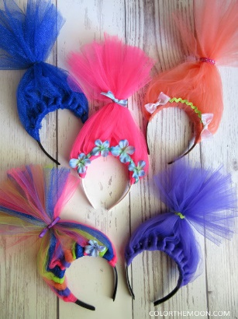 | 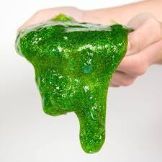  AM – Shrek Slime | AM – Jumping Minions | AM – Sing Microphones
Lunch 12-1pm  Please bring your own packed lunch | Lunch 12-1pm  Please bring your own packed lunch | Lunch 12-1pm  Please bring your own packed lunch | Lunch 12-1pm  Please bring your own packed lunch
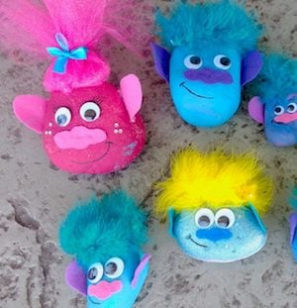  PM – Trolls Painted Rocks | 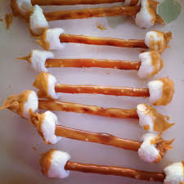  PM – Swamp Juice & Ear Wax Treats | 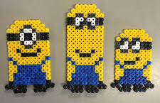  PM – Minion Hama Bead Art | PM – Sing Inspired Glasses
Snack between 3.30-4.30pm | Snack between 3.30-4.30pm | Snack between 3.30-4.30pm | Snack between 3.30-4.30pm
Busy Bees Summer Holiday Club 2024
Week 2 – Sports Week
Monday 29th July  Breakfast between 8-9am | Tuesday 30th July  Breakfast between 8-9am | Wednesday 31st July  Breakfast between 8-9am | Thursday 1st August  Breakfast between 8-9am | Friday 2nd August  Breakfast between 8-9am
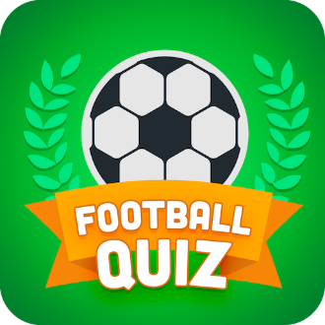  AM – Football quiz | 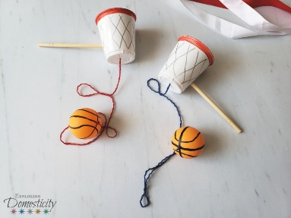  AM – Mini basketball craft | 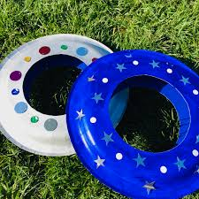  AM – Paper plate frisbee | AM – Team sports magnets  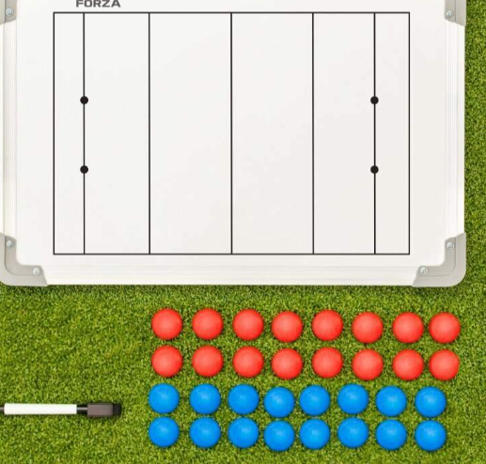 | AM – Tennis ball puppets  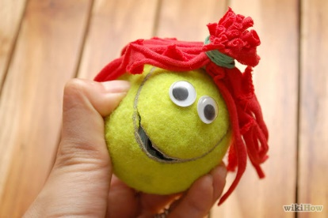
Lunch 12-1pm  Please bring your own packed lunch | Lunch 12-1pm  Please bring your own packed lunch | Lunch 12-1pm  Please bring your own packed lunch | Lunch 12-1pm  Please bring your own packed lunch | Lunch 12-1pm  Please bring your own packed lunch
PM – Football | PM – Running track | 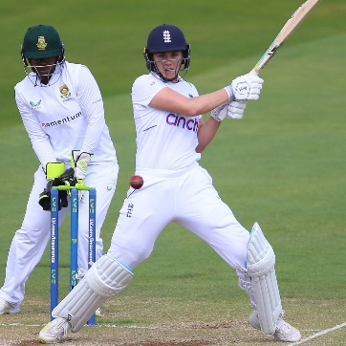  PM – Cricket | 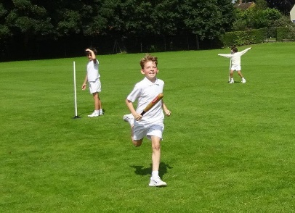  PM – Rounders | PM – Hockey
Snack between 3.30-4.30pm | Snack between 3.30-4.30pm | Snack between 3.30-4.30pm | Snack between 3.30-4.30pm | Snack between 3.30-4.30pm

Busy Bees Summer Holiday Club 2024
Week 3 – Disney Week

Monday 5th August  Breakfast between 8-9am | Tuesday 6th August  Breakfast between 8-9am | Wednesday 7th August  Breakfast between 8-9am | Thursday 8th August  Breakfast between 8-9am | Friday 9th August  Breakfast between 8-9am
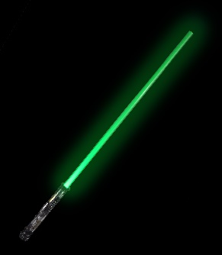  AM – Make Your Own Light Sabre | AM – Alien Cupcakes | AM – Pirates Treasure Hunt | AM – Disney Fancy Dress | 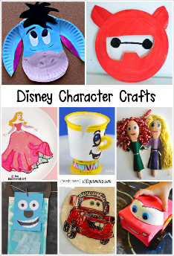  AM – Disney Paper Plates
Lunch 12-1pm  Please bring your own packed lunch | Lunch 12-1pm  Please bring your own packed lunch | Lunch 12-1pm  Please bring your own packed lunch | Lunch 12-1pm  Please bring your own packed lunch | Lunch 12-1pm  Please bring your own packed lunch
PM – Disney Games | 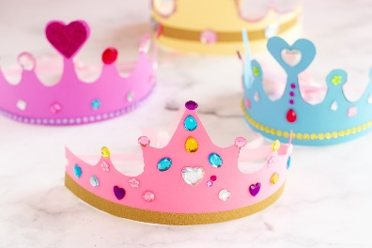  PM – Disney Crowns | 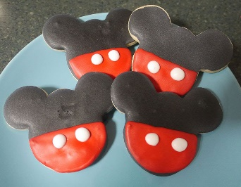  PM – Mickey Mouse Cookies | 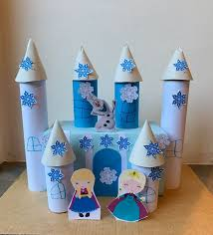  PM – Frozen Castle Competition | PM – Disney Movie & Popcorn
Snack between 3.30-4.30pm | Snack between 3.30-4.30pm | Snack between 3.30-4.30pm | Snack between 3.30-4.30pm | Snack between 3.30-4.30pm

Busy Bees Summer Holiday Club 2024
Week 4 – Dinosaur Week

Monday 12th August  Breakfast between 8-9am | Tuesday 13th August  Breakfast between 8-9am | Wednesday 14th August  Breakfast between 8-9am | Thursday 15th August  Breakfast between 8-9am | Friday 16th August  Breakfast between 8-9am
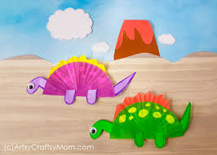  AM – Dinosaur Craft | 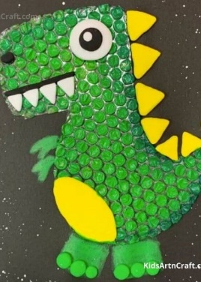  AM – Bubble Painting Dinosaurs | 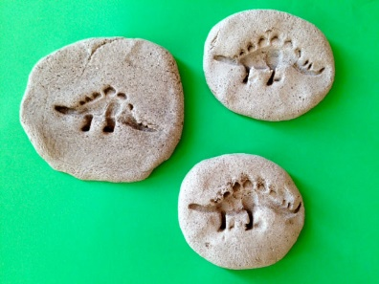  AM – Salt Dough Fossils | AM – DIY Dinosaur Balloons | 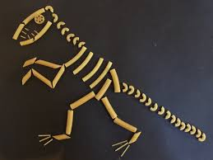  AM – Pasta Skeleton Pictures
Lunch 12-1pm  Please bring your own packed lunch | Lunch 12-1pm  Please bring your own packed lunch | Lunch 12-1pm  Please bring your own packed lunch | Lunch 12-1pm  Please bring your own packed lunch | Lunch 12-1pm  Please bring your own packed lunch
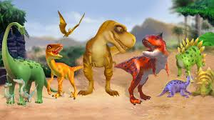  PM – Dinosaur Games | 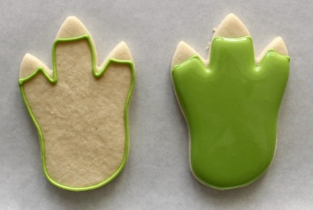  PM – Dinosaur Foot Biscuits | PM – Dino Egg Activity | 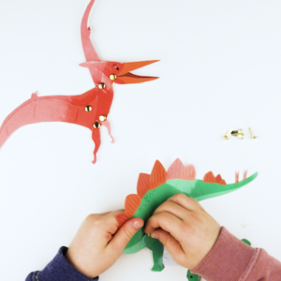  PM – Dinosaur Pins | 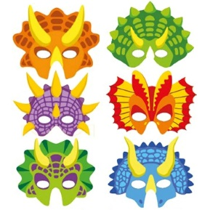  PM – Dinosaur Masks
Snack between 3.30-4.30pm | Snack between 3.30-4.30pm | Snack between 3.30-4.30pm | Snack between 3.30-4.30pm | Snack between 3.30-4.30pm

Busy Bees Summer Holiday Club 2024
Week 5 – Around The World

Monday 19th August  Breakfast between 8-9am | Tuesday 20th August  Breakfast between 8-9am | Wednesday 21st August  Breakfast between 8-9am | Thursday 22nd August  Breakfast between 8-9am | Friday 23rd August  Breakfast between 8-9am
AM – English Tea Pot Craft | AM – Italian Pizzas | AM – Spanish Maracas  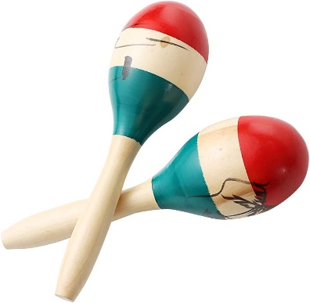 | AM – American Flag Handprints  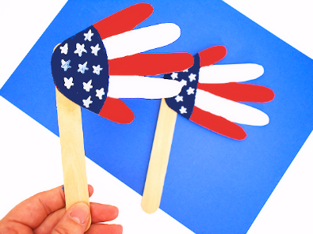 | AM – Chinese Drums  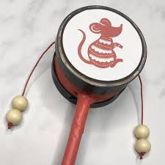
Lunch 12-1pm  Please bring your own packed lunch | Lunch 12-1pm  Please bring your own packed lunch | Lunch 12-1pm  Please bring your own packed lunch | Lunch 12-1pm  Please bring your own packed lunch | Lunch 12-1pm  Please bring your own packed lunch
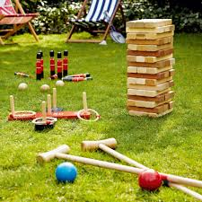  PM – English Outdoor Games | PM – Italian Flags | PM – Spanish Dancing | PM – Basketball  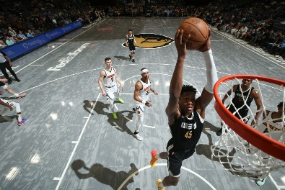 | PM – Fortune Cookies
Snack between 3.30-4.30pm | Snack between 3.30-4.30pm | Snack between 3.30-4.30pm | Snack between 3.30-4.30pm | Snack between 3.30-4.30pm

Busy Bees Summer Holiday Club 2024
Week 6 – Seaside Week

Tuesday 27th August  Breakfast between 8-9am | Wednesday 28th August  Breakfast between 8-9am | Thursday 29th August  Breakfast between 8-9am | Friday 30th August  Breakfast between 8-9am
AM – Jar Aquarium  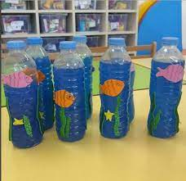 | 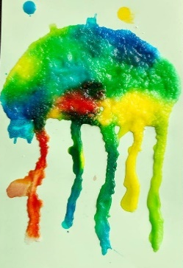  AM – Jelly Fish Salt Painting | AM – Making Ice Lollies | AM – Sand Jars
Lunch 12-1pm  Please bring your own packed lunch | Lunch 12-1pm  Please bring your own packed lunch | Lunch 12-1pm  Please bring your own packed lunch | Lunch 12-1pm  Please bring your own packed lunch
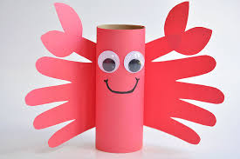  PM – Crab Paper Roll Craft | PM – Beach Ball Games  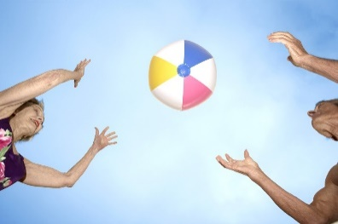 | PM – Water Fight! | PM – Beach Party
Snack between 3.30-4.30pm | Snack between 3.30-4.30pm | Snack between 3.30-4.30pm | Snack between 3.30-4.30pm

