 | Autumn 1 | Autumn 2 | Spring 1 | Spring 2 | Summer 1 | Sumer 2
Texts | -Arthur and The Golden Rope  -A small dragon  - The king who banned the dark   | - Until I met Dudley  - Rosie Reveer Engineer  - This book thinks you’re an inventor  - How everything works  - Starbird  - Zeraffa Giraffa  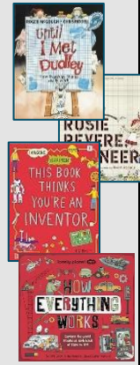 | - Real Life Mysteries  - Africa amazing Africa  - Take a bite  - India incredible India  - The big book of the UK   | -Leon and the place between  -The works: every kind of poem you will ever need at school  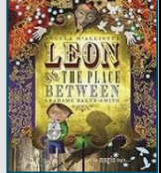 | -Malala’s Magic Pencil  -Greta and the Giants  -Stars with Flaming Tales  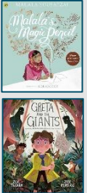 | - The girl who stole an elephant  - Marshmallow Clouds  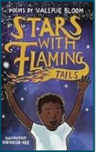  
English and SPAG | Writing outcomes:  Graphic novel  Persuasive speech  Poem (free verse)  SPAG:  pronoun, conjunction,  preposition, adverb  Review: expanded noun  phrase, noun, verb, adjective,  inverted commas | Writing outcomes:  Explanation  Narrative  pronoun, adverbial, fronted  adverbial  Review: comma | Writing outcomes:  Newspaper article  Travel leaflet  SPAG:  fronted adverbial  Review: present perfect  tense, comma | Writing outcomes:  Narrative  Poetry (haiku)  SPAG:  pronoun, possessive pronoun Review: expanded noun phrase | Writing outcomes:  Persuasive speech & letters  Non-chronological report  SPAG:  plural possession, adverbial,  fronted adverbial | Writing outcomes:  Short story  Poetry (focus on figurative  language)  SPAG:  Review terminology from the  year
Science | Living things and their habitats | States of Matter | Sound | Electricity | Habitats | Digestive system  &  Food Chains
Topic  (History or Geography) | Roman Invasion of Britain | What is it like in the UK? | Ancient Greece | What are rivers and how are they used? | Anglo Saxons | What is life like in the Alps?
ART/DT | ART- Drawing: Power Prints  Sculpture and 3D mega materials | DT-Structure Pavilions | ART- Every Picture Tells a story | DT- Digital world: Mindful Moments timer | ART- Art and Design Skill | DT-Electrical systems torches
Maths | Place Value  Addition/Subtraction | Measurement: Area  Multiplication and Division | Multiplication and Division  Measurement: length and permitter | Fractions  Decimals | Decimals  Money  Time | Statistics  Properties of Shape  Direction
Music | Ukulele | Ukulele | Ukulele | Ukulele | Ukulele | Ukulele
RE | How do ancient stories influence modern celebrations? |  | How do the 5 pillars help Muslims to lead a good life? |  | How do different people express their spirituality? | Why do people follow inspirational leaders?
Life Skills  (PSHE/RSE) | VIPs  (Relationships) | Safety First  (Health and Wellbeing) | One World  (Living in the Wider World) | Digital Wellbeing  (Relationships) | Money Matters  (Living in the Wider World) | Think Positive  (Health & Well-being)
PE | Fitness & Dance | Athletics & Dance | Gymnastics & Handball | Gymnastics & Football | Rounders & Orienteering | Cricket & Tennis
Computing | Online Safety/Effective Searching | Effective searching/ Coding | Artificial intelligence /Animation | Logo/Hardware investigators | Writing for different audiences/Making Music | Micro Bits

